**Unit 27 – Artificial Intelligence**

**A.I - Approaches in Intelligent System**

**Secret Intelligence Service MI6 - Criminal Detection System**

horizontal line

# 

# Introduction

This report will analyse the theoretical foundation of artificial intelligence, current trends and issues to determine the effectiveness of AI technology. Also implementing an intelligent system using a technique of the top-down approach of AI. This will also cover intelligence system using a technique of the bottom-up approach of AI.

## Top-Down And Bottom-UP Approach

**Top Down**

Top-down approach is a hierarchically approach that is organized from (top to bottom) architecture. The knowledge which is necessary is already programmed into the knowledge database. It also involves analyse computation, creating, manipulating and linking symbols. It is also preferred for the use of knowledge that was previously used to proceed with the study which helps to understand the concept more clearly. It deals with tasks which require high level thinking which is applied in complex programming in AI. It is an approach to logic from an already existing system with intelligence. The results are amazing in the form of systematic understanding. Top-down approach has the most responsive results as compared to bottom-up approach. AI is treated as a high level creation which can think for itself and complete low level tasks which is more mechanical as compared to a human brain behaves where it has to break down the tasks into simple and easier section to complete.

There are three steps in top-down approach the first step is obtaining the best set of linguistic terms, the second finding the matching rule antecedents and their output values, the third step is the neighbouring terms system which visits the nearest neighbour from different points on a graph. It reduces the memory required to process the information and results in a more efficient method than to manually search the fastest route in the graph.

Here is an example of a top-down approach where it uses fuzzy logic model in everyday tasks which finds the most fastest efficient route to go about the task. The most common method in this method is the salesman problem requires us to find the fast route across the map which uses the most efficient way possible to get all the houses on the way around the town, which is a great example for fuzzy logic in top-down approach.

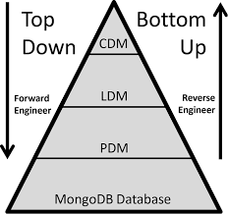

**Bottom Up**

Bottom-up is based on action and reaction, what this means is that for an action there is a reaction when there is a sense, this method is usually used for low level tasks which do not need that much knowledge in terms of complexity which is usually used in speech recognition and robotics. The has created a genetic algorithm which solves complex problems. This approach would be the best way to create human kind of intelligence but this is not the most efficient method of going about developing AI intelligence this makes top-down approach more approachable than bottom-up as it keeps all forms of logic into separate sections. It is a simulation of neurons which emit within the brain like a human which communicates by sending information from one part to another in response.

The nature of bottom-up approach is beneficial to A.I where it needs to set objectives to accomplish task along this way. This is essential for the A.I as it keeps track of it’s progress for future tasks but this would take a lot of time before the Expert system is populated with enough data for the AI to work with, which is not the ideal way to approach this method.

It is also used in developing nanotechnologies which uses strategies to approach ideal developing conventional strategies, whereas in top-down approach is used as a countermeasure to develop molecular manufacturing strategies.

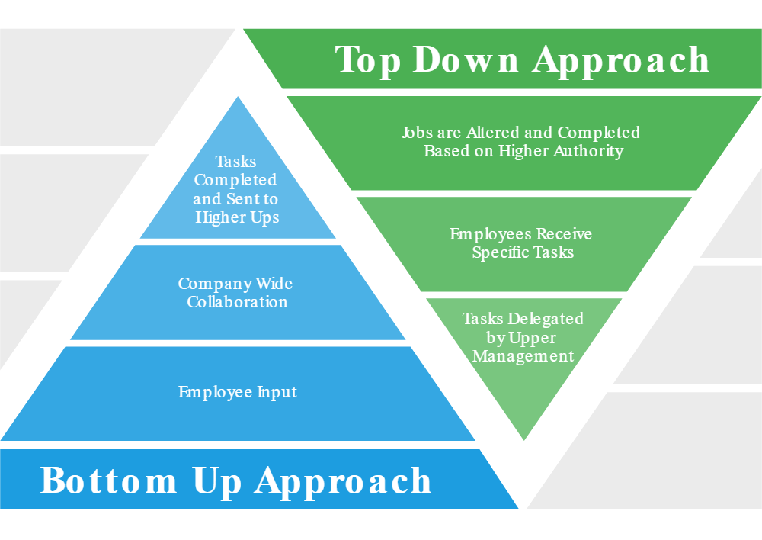

### Conclusion

This report investigating the top down approach of AI and its techniques and shows how these techniques have been used to build intelligent systems. It investigate the bottom up approach of AI and its technique of AI and shows how these techniques have been used to build intelligence systems. It also discusses how AI has changed the world in the last two decades and evaluates the ethical, social and philosophical issues of AI and how AI might change an individual’s lifestyle in the future.

### Bibliography -

Flickspin.com. (2019). *Artificial Intelligence - Top-down vs Bottom-up Approaches to Strong AI*. [online] Available at: http://www.flickspin.com/en/artificial_intelligence/ai_top_down_vs_bottom_up [Accessed 19 Nov. 2019].

Alan Turing.net. (2019). *AlanTuring.net What is AI? Part 9*. [online] Available at: http://www.alanturing.net/turing_archive/pages/Reference%20Articles/what_is_AI/What%20is%20AI09.html [Accessed 19 Nov. 2019].

Hbcse.tifr.res.in. (2019). *Top-down vs. bottom-up approaches*. [online] Available at: http://www.hbcse.tifr.res.in/jrmcont/notespart1/node45.html [Accessed 19 Nov. 2019].

Taylor & Francis. (2019). *Top-Down Approach for a Linguistic Fuzzy Logic Model*. [online] Available at: https://www.tandfonline.com/doi/abs/10.1080/01969722.2014.862118?journalCode=ucbs20 [Accessed 19 Nov. 2019].

Smartsheet. (2019). *Top-Down vs. Bottom-Up Approach | Smartsheet*. [online] Available at: https://www.smartsheet.com/top-down-bottom-up-approach [Accessed 19 Nov. 2019].

GameDev.net. (2019). *Does the Top-down or Bottom-Up Approach Best Model the Human Brain?*. [online] Available at: https://www.gamedev.net/articles/programming/artificial-intelligence/does-the-top-down-or-bottom-up-approach-best-model-the-human-brain-r561/ [Accessed 19 Nov. 2019].